**WHY EFC 118 IS THE GREATEST CARD OF 2024!**

9 OCTOBER, 2024

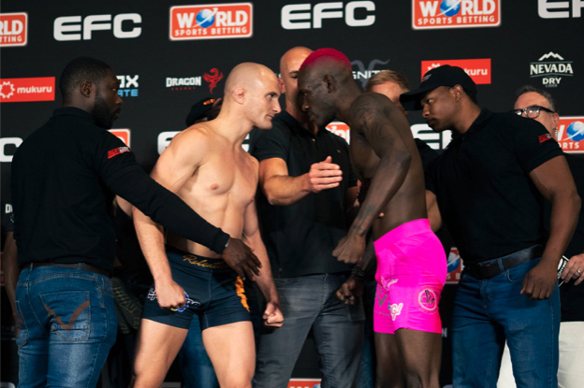

*Sunninghill Johannesburg, 9 October 2024:  Get ready for an electrifying night at EFC 118, where South African MMA stars are set to shine in an all-South African main card that promises intense action and dramatic showdowns amongst a plethora of former champions taking on the hungriest of new blood on the continent.*

In the headline interim featherweight championship bout, TUF star Roedie Roets returns to the Hexagon with his sights set on a championship title. Weighing in at 144.3**lbs,** he comes in as the favourite at World Sports Betting against Ayanda Zwane, who tipped the scales at 143.1 **lbs.** Both athletes are aware that a victory here could be a stepping stone to entering the UFC, adding even more stakes to this thrilling encounter. With Roets’ relentless grappling style and The Power's raw knockout ability, this bout is set to be a showcase of skill and heart.

**The co-main event features a surprising replacement as Hanru “The Bully” Botha is unable to compete gifting an opportunity for Cole “The Hitman” Henning to face a legend. The** devastating knock-out artist Henning displayed his usual stoic confidence at the scale in front of a primed opponent, the veteran fan-favourite Martin “The Punisher” Van Staden who refused to break his gaze and is the overwhelming favourite at World Sports Betting.

A fascinating welterweight contest sees Peace Ngupane taking on another veteran in Jason Culverwell, who is making a triumphant return following a decade away from the sport. Ngupane is known for his youthful energy and agility, whilst Culverwell brings a wealth of experience and technical prowess. This bout could be a turning point for both athletes with fans expecting a dynamic contest of the old school against the new school.

Ntando Zondi who is undefeated with two wins under his belt is headlining the prelims and is an athlete to keep an eye on as he looks to maintain his perfect record. He takes on the unconventional and electrifying Godfrey Mkhwanazi and a fight that has built-up a lot of hype on social media and the enmity between the two threatened to flow over at the scale.

EFC 118 is stacked with talent, showcasing some of the best athletes in the region. With the fighters having made weight and the atmosphere charged with anticipation, all eyes are on the Hexagon for what promises to be a sensational night of MMA action culminating in the incredible title fight. Don’t miss the opportunity to witness the rising stars and seasoned veterans battle it out for glory.

**Main Card**

**INTERIM FEATHERWEIGHT CHAMPIONSHIP**

Roedie Roets (SA) 144.3 lbs vs. Ayanda Zwane (SA) 143.1 lbs

**WELTERWEIGHT BOUT**

Martin van Staden  (SA) 167.7 lbs vs. Cole Henning (SA) 168.8 lbs

**WELTERWEIGHT BOUT**

Peace Ngupane (SA) 168.4 lbs vs. Jason Culverwell (SA) 169.5 lbs

**FEATHERWEIGHT BOUT**

Billy Oosthuizen (SA) 143.7 lbs vs. Rian Dunn (SA) 143.1 lbs

**WELTERWEIGHT BOUT**

Elbert Steyn (SA) 170.8 lbs vs. Given Majuba (SA) 169.7 lbs

**Prelim Card**

**FLYWEIGHT BOUT**

Ntando Zondi (SA) 125.2 lbs vs. Godfrey Mkhwanazi (SA) 125.1 lbs

**FLYWEIGHT BOUT**

Micky Cloete (SA) 124.8 lbs vs. Kelvin Smit (SA) 125 lbs

**FEATHERWEIGHT BOUT**

Lucky Magekha (SA) 144.2 lbs vs. Emerson Pedro (MOZ) 145.2 lbs

**FLYWEIGHT BOUT**

Lihle Ngamntwini  (SA) 123.4 lbs vs. Siyanda Vilikazi (SA) 124.3 lbs

**CATCHWEIGHT BOUT**

Guide Moyo (ZWE) 158.6 lbs vs. Glody Kanzeko (DRC) 157.2 lbs

**CATCHWEIGHT BOUT**

Chadrack Yemba (DRC) 150.8 lbs vs. Nkosi Doyisa (SA) 150.9 lbs

**FLYWEIGHT BOUT**

Mpumelelo Mngoma (SA) 121.3 lbs vs. Tyral Louw (SA) 118.8 lbs

Prelim bouts start at 15:00 CAT

Main card bouts start at 19:00 CAT

**EFC 118 is presented by World Sports Betting and takes place on Thursday, 10 October 2024, live from the World Sports Betting EFC Arena in JHB, South Africa.**